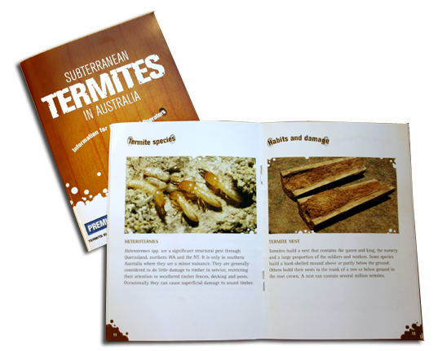
Trade offer
Free Termite Identification Guide Available From Bayer Environmental Science
Available with the Purchase of every bottle of Premise® 200SC Termiticide

Bayer Environmental Science is pleased to announce that a limited number of Premise 200SC termiticide bottles have been made available with a FREE Bayer Termite Identification Guide.

Professional Pest Controllers continually tell us that they are concerned about product safety, just as we are. That’s why we recommend Premise. Premise has extremely low volatility, which means there are no airborne chemicals, virtually no odour and a low risk for exposure. “The home owner and pets can even stay in the home during treatment with no worry,” said David Priddy, Business Manager for Bayer Environmental Science.

Pest Control Managers will be able to grab their ID guides from Garrards when they purchase Premise termiticide. Due to the limited quantities, they are available on a first come, first serve basis.

Each identification guide contains full-colour images of the most common termite species along with biology and control tips, making it a great reference tool for technicians.

Premise is the premium non-repellent termiticide providing immediate structural protection. To date, Premise has successfully treated over one hundred thousand homes in Australia during the last 7 years and countless millions around the world. Imidacloprid, the active ingredient in Premise, is the most widely used insecticide in the world and is commonly used in consumer products for both people and pets. For more information on Premise visit our website at www.premiseguarantee.com.au or call 1800 223 002.

Premise is a Registered Trademark of Bayer © 2003

